Communication Examples to Election Chair Guidance.docx
AS OF APRIL 13, 2024

INDEX TO KEY ELECTION DOCUMENTS
INCLUDED IN THIS DOCUMENT: #1, #2, #3
- NOMINATIONS CHAIR MESSAGE TO BOD CANDIDATES
- ELECTION CHAIR MESSAGE TO CANDIDATES
- FOLLOWUP, ELECTION CHAIR MESSAGE TO CANDIDATES
- 2024 ELECTION PAGE FROM SCWDC WEBSITE

EACH OF THE FOLLOWING ARE SEPARATE DOCUMENTS
- AGENDA SENT TO PRESIDENT, ALSO INCLUDES LIST OF OFFICERS AND SUGGESTED # OF COPIES TO REPRODUCT
- ELECTION MEETING SCRIPT SENT TO PRESIDENT
- DRAFT BALLOT SENT TO GARY FOR POSTING ON WEBSITE

- NOMINATIONS CHAIR MESSAGE TO BOD CANDIDATES

-------- Original message --------
From: Geoffrey Pennoyer <cometjeff.gp@gmail.com>

Date: 2/21/24 2:21 PM (GMT-05:00)

To: BOD CANDIDATES

Subject: SCWDC Nominations for Board of Directors Bio's

Hello all, during the previous couple of months you were contacted by a member of the nominations committee and expressed a desire to be a board member. You will need to write a short bio that will be described below. I have attached a summary of the responsibilities.

The board meets 1x a month. There may be an occasional meeting if an emergency should arise. The meetings are Zoom for 11 months, a holiday lunch for 1 month. Expect the meetings to last about 1.5 - 2 hours, sometimes a little longer. If you wish to be on a committee, it might be longer. It is optional if you want to be on a committee or not.

There is an election that is held at the annual club meeting in April. At that time, the membership votes are counted according to the ski club policy manual. All nominees must submit a short bio and photo that will be published in our web magazine. I have attached copies of previous magazines that have bio's in them. You can use those as guides. In general, the shorter - the better.

We have 6 nominees for 5 open positions. 4 of the positions are for 2-year terms, 1 is for a 1-year term to fill in for a person who will resign at the end of our fiscal year (March 31). It is possible for a nomination to come from the floor at the meeting but that is rare. There will be a request for nominees that will be published in a future Ski-O-Gram.

Here are the current nominees; BJ Barger, Rita Togni, Carol Caruso, Joe Trincellito, William (Max) Maxwell, Ellliot Greenwald.

If you have any questions or concerns please contact me.

Good Luck!

v/r,
--
Geoffrey Pennoyer
SCWDC Nominations Chair, (202) 702-6044

#2
ELECTION CHAIR MESSAGE TO CANDIDATES

On Sunday, February 25, 2024 at 06:51:31 PM EST, Bill Johnston <bjohnston2@aol.com> wrote:
This is Bill Johnston writing, I am the SCWDC 2024 Elections Chairperson. I have served in this role for the past four years.
I am sending this by ‘blind copy’ to each addressee: 2024 candidates for office; Gary Rubens, Membership and Communications Chair & Webmaster; and Geoffrey Pennoyer, Nominating Committee Chair.
Congratulations on being selected by the SCWDC Nominating Committee to run for the position of SCWDC Director or President.
Importance of Individual Volunteer Efforts
The Club’s existence from the beginning to now has been based on volunteer efforts. In the last two years, about 150 different volunteer roles were performed by about 100 members. There is often a period of life where an individual can only devote himself or herself to family, career, and personal matters, but later has the time to contribute to the SCWDC. You have answered the call to become a key SCWDC volunteer. Thank you for volunteering to serve.
About your future duties: The BOD is scheduled to meet once a month, mostly by video connections and a few in person. A list of BOD authorities and responsibilities can be found in the SCWDC Policy Manual, Chapter 4. The manual is posted on the SCWDC website.
List of Candidates:
President running for a one-year term April 2024 – April 2025
Ruth D’Alessandro at radal16@cox.net & 703-795-3395
Director Candidates running for a two-year term April 2024- April 2026
(The email and primary phone info below is from your membership record, please let me know if want to change these.
BJ Barger at bjbarger@verizon.net & (703) 836-2463
Carol Caruso at carol.caruso@comcast.net & (703) 835-6762
Eliot Greenwald at eliot.greenwald@verizon.net & (202) 841-5666
William (Max) Maxwell at womaxwell703@gmail.com & (703) 299-6218
Rita Togni at rita.togni@longandfoster.com & (703) 405-6710
Joe Trincellito at jtrince@aol.com & (703) 807-0496
My purpose in writing is to explain the election procedures and plans, and what you need to do as a nominee. The Election and Awards meeting is tentatively planned for Thursday, April 18, 7:00 PM at the Auld Shebeen restaurant in Fairfax City. Its address and more meeting information are listed at the end of the document. After you read this message, would you reply that you have received it? Thank you. I would like to briefly talk to each of you after you have had time to read this message.
I’ve tried to write an all-inclusive message to you – it’s a bit long, but I am required to provide this to you.
Here’s the first step for you to take as a candidate: Please compose a campaign statement and provide a photo of yourself, both will be posted on the SCWDC website’s 2024 Election page. Would you send them to me by Wednesday, March 6?
Further down, I will describe the type of statement and kind of photo, and where to look for prior examples.
FYI: Due to the lifting of national, state, and local Covid-19 restrictions, the 2024 Election Meeting will be in-person, as was the 2023 Election Meeting. Election meetings 2020-2022 were conducted remotely due to COVID, now the President and Board of Directors believe it is safe to conduct an in-person meeting.

Club Election Business Criteria
I am required to check that if you are nominated, you agree to serve if elected. I am going to consider that each of you is willing to serve if elected unless you change your mind and write or call me before the election is held.
Another criterion is whether you are a “skier” within the last three years, although you don’t have to be. Our Bylaws allow for up to four non-skiers to serve on the Board of Directors (BOD). “Skier” is defined in this way, downhill skiing, cross-country skiing, or snowboarding at least once in any of three recent ski seasons, 2022-20242. The skiing can be on an SCWDC trip or privately. All four current BOD members are skiers and most candidates are skiers, so this criterion does not apply.

Your Input is Necessary, A Candidate’s Statement
Deadline? By March 6, please compose and send your statement. Please send your statement to me, Bill Johnston at bjohnston2@aol.com and Gary Rubens at gkrubens@verizon.net.
Length? President, 400 words; Director, 300 words, but when a statement goes beyond these, the limits are not strictly enforced. The suggested numbers come from the time when SCWDC published a magazine, but it has been discontinued. So just write what you want to say about yourself or candidacy.
Content? Is there a club template for the candidate statement? No, there is not, your statement can take any form or content. Other candidates have written about their club experiences…why they belong, professional career or avocations, what goals or projects are believed to be good for the club, and so on. You can look at the 2023 Election web page 2023 Election Page for other candidate statements and look at past issues of the magazine posted in the “Home” area, “SCWDC Magazines”: 2022 Spring Summer, 2021 Spring Summer, 2020 Spring Summer, 2019 January/February/March. SCWDC-Magazines.
You can also call me to discuss your statement in general terms, but what you turn in as “yours,” will not be edited for content.
Photo? It’s your choice, to provide a “headshot” / or a closeup or an activity photo of your whole body – perhaps as a skier or golfer, or just simple photo of yourself.
Email or text me your photo when ready.
Key Point: I will make this comment about recent election experiences: The club adopted electronic voting several years ago. Since that time, the total number of ballots cast in advance has been over 200. The result is, the candidate’s written statement is what most members use to consider their vote by advance-voted ballot.
Campaigning
Any campaigning you wish to do can begin immediately. Your nominations will be announced sometime in the future in the Monday Skigram in connection with a paragraph about the election meeting. I do not know when the announcement will be made.
Speech: The club would like you to attend in person and make a short “speech” – something not longer than two minutes. There is no club template for the speech, you can summarize your candidate’s statement or just introduce yourself.
About the Election Procedures – Please Read Them, Follow Them
The Club has written official election guidance in several places. The most important is the “SCWDC Election Guidelines” included in the SCWDC Policy Manual as Appendix 5. A copy can be found below my signature. Please read and comply with them to the best of your ability. If you have any questions or concerns, please contact me. You can email me at bjohnston2@aol.com or call me on 703-597-6310.
After you read this message, would you reply that you have received it? Thank you.
It's Sunday night about 7PM when I am sending this out.
All of you have been fairly longtime members, so you have enjoyed the club in various ways. Thank you again for volunteering.
Bill Johnston, 2024 Election Chairperson
====
Tentative Meeting Location on April 18, 7:00-10PM
Auld Shebeen, Irish Bar and Restaurant, 3971 Chain Bridge Rd, Fairfax, VA, Phone: 703-293-9600. See the restaurant’s web site at https://theauldshebeenva.com/ and open the webpage which provides a map and parking options.
Overview about directions: This restaurant is near the intersection of Main Street and Chain Bridge Road in Fairfax City. For members coming from Maryland and VA cities east and south of Fairfax County, I am informed that I-66 travel is not as complicated as it once was since the I-66 Express lanes and other improvements were made. Note, Daylight Savings Time begins in March, so travel in the late afternoon and evening during April will be easier. “Rush Hour” traffic cannot be avoided but hopefully it will not prevent excellent attendance. This is the club’s second time holding the election meeting at the Auld Sheeben. The first time was considered a success, about 100 members attended.
About the meeting, all members and guests will be requested to sign up on the website at no charge, indicate their intention to attend so planners know how much food and drink to provide. Water and soft drinks will be served at no charge. Alcoholic beverages will be available for purchase. Appetizers will be served. A few members arrive early to eat dinner at the restaurant. Again, see the restaurant’s website at The Auld Shebeen especially to see parking options.
CLUB ELECTION PROCEDURES
Below comes from the SCWDC Policy Manual, located in the “Home” menu item, and “Club Forms and Documents.” It is provided below to save you time from going to the website.
“APPENDIX 5, SCWDC ELECTION GUIDELINES & PROCEDURES
A. Candidates and Campaigns
1. The Club shall reproduce, at its expense, the campaign article and photo for each candidate. The Club shall distribute these to each member attending the Election Meeting.
2. Articles or notices about the election, including campaign articles, must be submitted to the Election Chairperson for approval before being submitted to the Club magazine, website, or Ski-O-Gram newsletter.
3. Campaigning, which may commence when the Nominating Committee first announces its nominees to the general membership, is allowed at all Club activities through election night. This campaign start date applies to all candidates, regardless of whether they are nominated by the Nominating Committee. Campaign activities include the passing out of fliers, buttons, and name tags; the display of posters; and the public promotion of a candidacy, either in person or by telephone, mail, email, or other electronic means of communication.
4. Candidates may use personal mailing lists, but they may not use lists generated from the Club membership database that are not available to members at large.
5. Use of SCWDC facilities or office equipment for campaign purposes is not permitted.
6. Endorsement or promotion of candidates by members while acting in an official Club capacity (e.g., as an activity leader, assistant, or volunteer) is not permitted. This includes the wearing of buttons, name tags, or slogans that might be interpreted as promoting a candidate. This restriction applies before the activity, while conducting business associated with the activity, and during the activity.
7. Candidates shall conduct themselves in accordance with the Club’s Code of Ethics. Malicious behavior, bribery, and false statements about other candidates are not permitted.
8. At the election meeting, Board candidates’ speeches will last a maximum of two minutes. Presidential candidates’ speeches will be a maximum of four minutes. Any candidate running for both offices simultaneously is limited to four minutes.
9. All candidates for Club office are subject to these guidelines, whether nominated by the Nominating Committee, by petition, or from the floor.
10. Each candidate is responsible for compliance with campaign guidelines on the part of those campaigning on his or her behalf.
11. If violation of these guidelines occurs, the Election Chairperson may ask the offending candidate to stop campaigning. The candidate will then only be allowed to make his or her speech at the election meeting. If a serious violation occurs, the candidate will be informed in advance by the election Chairperson that announcement of the violation may be made at the time the candidate is introduced for the speech. The Election Committee can apply an appropriate sanction. Prior to the day of the election, the candidate may appeal this action to the President. If the President is a candidate or recuses himself/herself, the appeal shall go to the Board of Directors, who shall resolve the matter expeditiously. Any appeal on the day of the election shall be presented to the assembly of members at the meeting.
B. Election Procedures
1. The Election Chairperson shall assume responsibility for all aspects of the election process. Upon nomination, candidates for Club office immediately come under the purview of the Election Chairperson, who shall ascertain that all nominees meet the requirements for nomination. All disputes, questions of procedure, etc., should be forwarded to the Election Chairperson for resolution.
2. The Election Chairperson will appoint a committee of at least two other Club members to assist the Chairperson. At the election meeting, the Election Chairperson and committee members will each wear readily visible badges or ribbons identifying them as election monitors, providing a reminder to candidates and their campaigners that the monitors' directions should be followed.
3. If the Board of Directors consists of eight members, the four candidates with the most votes will be elected to two-year terms on the Board. Ballots shall state that members may vote for no more than four candidates. If there are additional vacancies on the Board at the time of the election, the individual(s) with the next highest number of votes will be elected to fill the vacancies.
4. For the election of officers and for Bylaw proposals to the membership, votes may be cast either in person, by absentee paper ballot, or by absentee electronic voting. For both types of absentee voting, votes count only if received by the Club before the deadline set by the Elections Chairperson. All vote count information must be kept secret until the voting results are officially announced. An absentee paper ballot may be used for voting only if it is received directly from an official SCWDC source; and it may be reproduced only for members of the same household. An absentee ballot is counted only if the voter mails it directly to or delivers it in person to the Club office. These ballots shall be counted by the Election Chairperson and at least two additional counters approved by the Board.
Electronic voting serves the same purpose as absentee paper balloting but uses a different method. Any electronic voting system should be secure from fraud or misuse, prevent duplicate voting, and protect the privacy of voters and their selections. The Elections Committee must implement a procedure to ensure that any member’s voting selections are counted only once, given that a member can vote in more than one way.
Vote counts should be published on proposals; but not published regarding individual candidates for office.” (end of document)

#3
FOLLOWUP: ELECTION CHAIR MESSAGE TO CANDIDATES
The reason for this message is the selection of the date and location for the Election meeting.

On Saturday, March 16, 2024 at 10:03:28 AM EDT, Bill Johnston <bjohnston2@aol.com> wrote:

Hi Candidates,

Ruth D'Alessandro, BJ Barger, Carol Caruso, Eliot Greenwald, Max Maxwell, Rita Togni, Joe Trincellito

The Election and Awards Meeting is planned for 7PM, April 18 at the Auld Shebeen restaurant in Fairfax. The address and parking information will be posted on the SCWDC website soon, advance signup is required. With Daylight Savings Time and better driving conditions than wintertime darkness, it should be easy for members to get to the meeting. About 100 members and guests attended last year's meeting.

This week's Skigram, Monday, March 11, included an announcement about the election. All candidates' biographies/statements have been posted to the SCWDC website on webpage, "2024 Election." Please look this over, does your posted statement agree with what you submitted? I know some of you are on the Eurpopean trip running in the next seven days, please check your bio when you are back.

A few of you have said that you cannot attend the Election meeting due to prior commitments. As I wrote in my first message to you, most votes come in by advance electronic ballots using your biography/candidate statement as a guide.

I would like to recognize Geoffrey Pennoyer, Nominations Committee Chair for the 5th year, and also the members of his committee for finding "you","all of you" to run.

I will mention a few things about SCWDC:

If you are elected, there is usually a Board of Directors Meeting held the same night or scheduled for a few days after the election. The President will decide when and how the BOD meeting will be conducted and communicate this to you. This meeting usually involves selecting the Vice President and planning the dates of the next year's BOD meetings.

Many BOD meetings are conducted via a "Zoom" (video) session which requires an easy connection to the Zoom website using a computer, smartphone or tablet. Zoom has a fairly simple software system and it offers a test feature to check out your audio and video setup. It takes about 10 minutes to set this up on your computer or smart device.

Here are key references you can read to get ready to serve:
(1) Policy Manual, Chapter 4, "Authorities and Responsibilities" located on the club webpage, "Club Forms and Documents." Every club position is included in this section.
(2) The 2023 Audit for the period May 2023-April 2024 posted on the club webpage, "President's Message, BOD Minutes, and Audit Report." An independent auditor audits every year's financial activity. On the same page, BOD minutes are posted which you can read to get a sense of how the current and past BODs have managed club business.

Thank you for agreeing to serve; it's a big deal. We are a large group of socially and athletically active members who depend on the SCWDC for fun and activities. Our membership is 1,164 as of today. Our annual budget is about $1 million.

Candidates, I intended to call each of you to convey some of this information, but a relative who lives in Strasburg experienced a major medical problem, and I have been driving there and back almost every day since February 28, and didn't have the time to reach out. I am available to answer any questions you may have because my commitment to the family member has lessened.

Bill Johnston, 2024 Election Chair
cell 703-597-6310

Addressed to: President and BOD candidates, Gary Rubens (webmaster), Geoffrey Pennoyer (Nominations Chair), Office at scwdc@scwdc.org, Howard Fisher (Policy Chair)

2024 SCWDC Election (WEB PAGE)
SCWDC's upcoming election of officers and presentation of awards to volunteers will take place at the Annual Meeting on Thursday, April 18, 2024, at 7:00 PM. Location: the Auld Shebeen restaurant in Fairfax, 3971 Chain Bridge Road, Fairfax. More information including parking directions and a map are now posted in the meeting event for April 18 and advance registration is required. FYI, the April Happy Hour is also scheduled 5-7:00 PM at the same location.
How to Vote Overview:
- Electronic voting was enabled on April 8 and will continue until April 18. SCWDC sent electronic ballots to all active SCWDC members via email on April 8. In order to submit an electronic ballot, members must use the voting button enclosed in the email. If you did not receive such an email, your SCWDC membership may have expired.
- Votes may also be cast by requesting an absentee ballot from the SCWDC office, send an email to the office at scwdc@scwdc.org, see additional instructions below under "Voting Rules."
- Voting during the meeting will also be possible.
- Voting results will be announced at the meeting.
Voting Rules:
Only Active SCWDC members may vote. Expired members are not allowed to vote, so please ensure that your membership is up to date if you plan to vote. Early votes may be cast electronically, or by paper absentee ballot. Members may only submit one ballot. For Family memberships, if two or more members share the same email address, only one member may submit an electronic ballot. This is because the membership database uses the email address as the Member ID. Other family members may update their profile to include a unique email address or submit an Absentee Ballot.
Members can request an Absentee ballot from the Club office, by sending an email to scwdc@scwdc.org. Your membership will be confirmed, and you will receive, via reply email, a PDF ballot to be used for one vote. For a family membership, each individual wishing to vote via Absentee Ballot will need to request and file a separate ballot. Your Absentee ballot must be received in the Club office by April 5 (before 3 PM). Members who wish to vote in person can do so at the Club office from April 9 to April 15 (before 3 PM) but must call ahead (703-532-7776) to ensure that the Office Manager will be present to register their vote.

Candidates:
Any Active Club member who has been a member for one year or more may run for the position of Director. Any Active Club member who has been a member for three years or more may run for the office of President. Candidates must agree to serve if elected. The President and at least four of the Directors must be skiers. Members may run by petition, and nominations may also be made from attendees at the Election Meeting. For more detailed information about the Club's Bylaws, Rules of Procedure and/or Policies regarding Club Elections please refer to the SCWDC Policy Manual.
The Club's Nominating Committee has approved the following slate of candidates:
For the office of President, for a term of one year: Ruth D'Alessandro
For the position of Director, for a term of for two years: B J Barger, Carol Caruso, Eliot Greenwald, William "Max" Maxwell, Rita Togni, Joe Trincellito
Write-in candidates may be entered in the "Write-in" category.

Candidates for President:
Ruth D'Alessandro
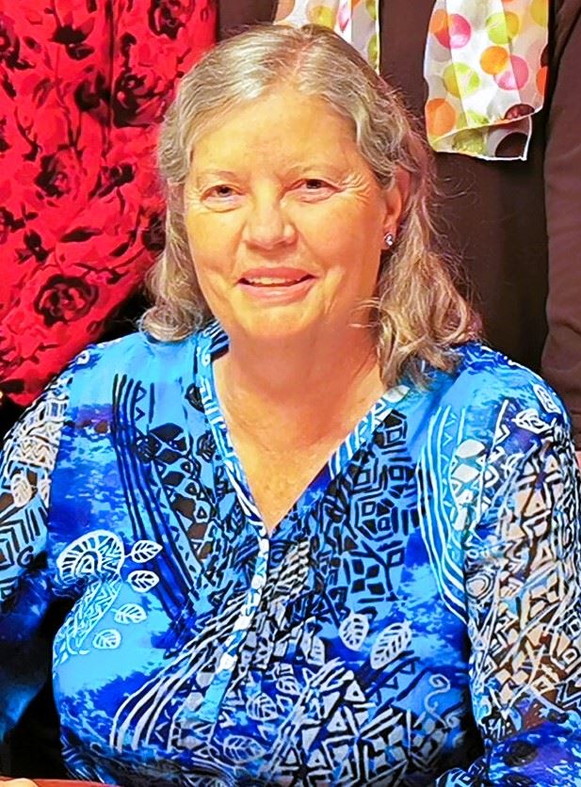
I am honored to be nominated for President of SCWDC now DBA (doing business as) Ski and Sports Club of Washington DC for the fourth year. I have been a member of our club for over 38 years. Initially, I participated in tennis parties, instructional tennis, weekend trips, weekly tennis, and played softball. I began skiing 3 years after I joined our club and benefited from many one day and weekend learn to ski trips. Since then, I have attended approximately 3 ski trips a year. I was the race coordinator on several ski trips, assisted trip leaders and hosted several pre-trip parties at my house. I have participated in Club Med and Viking Cruise trips. A few years ago, I led the Park City/SFF ski trip; and I was trip leader for Winter Park, CO ski trip. I also led a Club Med trip to Sandpiper Bay that over 40 participants safely attended in 2021. Three years ago, I researched the location, negotiated prices and assisted the trip leader on our first weeklong golf and tennis trip to Hilton Head Island, SC. Last fall, I led a second week-long golf trip to Hilton Head that 29 members attended. In November 2023, I led an enjoyable and successful golf trip to Kiawah Island in South Carolina.
Several years ago, I began participating in our Wednesday evening golf program. I led 4 weekend golf trips to Blue Ridge Shadows in VA and 2 successful weekend golf trips to Shenvalee, VA. I have met many interesting people and made numerous lifelong friends while enjoying being active in our club.
A few years ago, I was able to spend more time giving to give back to our club; I was nominated and elected to the (Board of Directors) BOD. I learned about our operations and budget. It was a difficult year due to COVID and we suffered financially. The BOD made prudent decisions to cancel some events. We discussed cancelling all events for the year including golf, tennis, and softball. However, the BOD determined that would be detrimental to our club and membership; many of our members wanted to participate in outdoor activities.
Since then, we have safely continued our outdoor activities including picnics in the spring and Back to the Slopes gatherings in the fall. Our biking, and hiking programs have been revitalized. Also, our indoor volleyball program resumed last fall. All of our outdoor activities and trips have been well attended. This year, for the first time since 2019, a VBT (Vermont Biking Tours) trip will being going to the Netherlands in April. As a result, we are doing well financially and have recouped most of our losses since Covid began. For the past two years, our ski trips have sold out. Our membership has increased by over 300 members. Also, every spring and fall since 2021 we have continued to go on Club Med trips.
Last April, we hosted an indoor election, awards, and party meeting for the first time since Covid began at Auld Shebeen in Fairfax City, VA. We will be holding our Annual Election, Awards ceremony and club gathering there again on April 18, 2024. Our annual picnic is scheduled at the Shipgarten on June 22, 2024 and we be featuring future travel trips, biking excursions golf trips and other activities as well as our ski trips for 2025. Our Back to the Slopes Party will be held in September 2024. In addition, the BoD is planning an indoor Volunteer Party in November 2024.
We have some new Volunteers for Leadership positions on the BOD, Flights Committee, Travel, and Sports and Recreation and Membership and Communication. We have a leader for the Volleyball Program and one of our members arranged for 14 members to see Quarterfinal action at a tennis event in Washington DC last August. We have not had a Social Chair for several years. Now that we are encouraging more indoor activities, we need a Volunteer for that position. We also need volunteers to lead trips including ski trips, Adventure trips, Tennis and Pickleball. Our club is a volunteer organization and we need more Volunteers to survive.
I have been described by friends and colleagues as enthusiastic, dedicated and hardworking. I have ideas/incentives to entice new volunteers to our club, new events and to continue to recoup our financial losses and build our club. Zoom is great but it does not take the place of human interaction and contact.
Lastly, I worked for Fairfax County Public Schools for 32 years as a Social Worker and an Administrator. The organizational, human relations and leadership skills utilized in my career have benefited me as I have been a volunteer, trip leader, member of the BOD and I hope your President for a fourth term.

Candidates for Director:
B J Barger
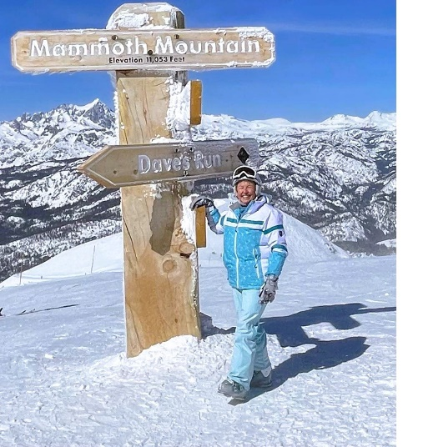
Greetings fellow members of the Ski and Sports Club of Washington DC! This is my third time to run for the board. I’ve been elected twice and I’m looking forward to the opportunity to serve again.
During my time on the board, we’ve moved out of pandemic restrictions and reinstated many popular programs. One big change during this time was changing our name to Ski AND SPORTS club. This recognizes the while array of activities we offer. Skiing is at our heart, but we’re aiming to provide a myriad of leisure time activities and travel.
I’ve gone on at least three ski trips with the club every year. Additionally, I’ve participated in golfing and biking outings and volunteered at activities like picnics and the annual meeting. This year I’m leading a biking trip to Amsterdam. My goal for my board participation is to continue our outstanding skiing adventures while expanding other social and travel experiences. I also strongly support efforts to broaden our perspectives and look for younger members.
I’m retired from a career as a civilian with the Air Force where I served in Human Resources with an emphasis on Training and Development. During my time with the Air Force, I’ve joined many ski clubs: Ohio, Germany, Japan, and Colorado Springs. I picked up great ideas from all of those clubs.
In my retirement, I serve as an officer for my Homeowner’s Association as well as with several golf organizations including American Singles Golf and Ladies Professional Golfers Association Amateurs.
I’ve taken advantage of many opportunities provided by the SCWDC. Thanks for giving me the chance to give something back.

Carol Caruso
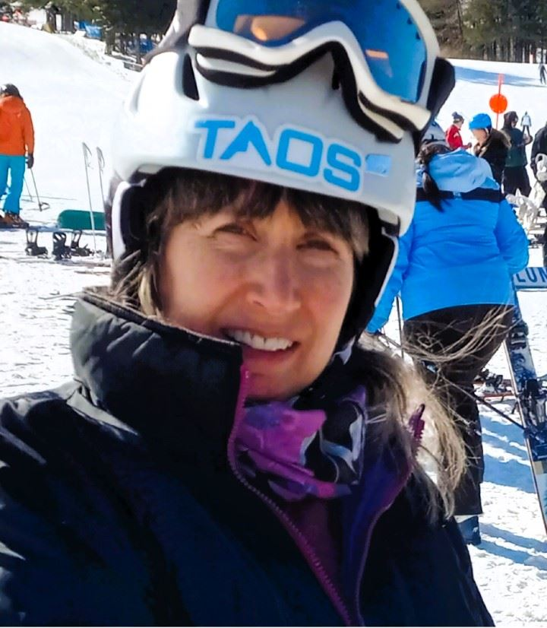
I have been an active SCWDC member for more than 10 years; I have enjoyed many hikes, bike rides, ski trips, adventure trips, and social events. I would like to show my appreciation for the club by giving back and volunteering on the Board. The experiences that I have had, by participating in a wide range of club activities, will give me the background and basic knowledge needed as a first-time board member. In addition, I am now retired and have more time available to focus on contributing to the success and growth of the SCWDC.
Skills developed throughout my professional career will enable me to help the club accomplish goals and carry out operational tasks and processes, ultimately benefitting the club and its members. Specifically, I have degrees in Computer Science, and Information Technology from Monmouth University and George Washington University. My work experience is from a career with the Federal Government where I performed problem solving, software coding, and project management (budgeting, personnel resource management, project planning, and scheduling).
Thank you for taking the time to read my bio and for your consideration!
Eliot Greenwald
I have been an active member of SCWDC since 1977 and have been on over 100 ski trips. Most noteworthy was a ski trip to Greek Peak, NY over Martin Luther King weekend in 1986, where I met my wife Anita. Although I was never a trip leader back then, I was friends with many of the trip leaders and offered to help out during the trips, often coordinating the NASTAR race. I continue to ski with the club and participated in two flight trips this past season.
I also have been an active participant in the SCWDC sailing program for over 20 years, including volunteering as a trip leader and skipper on many of the Potomac sails. Having just retired at the end of 2023 from a 47-year career as a telecommunications attorney, I now have time to give back to SCWDC. I volunteered to chair the sailing program starting this past fall and agreed to be nominated to run for the Board of Directors.
In addition to SCWDC, I have considerable experience with volunteer organizations. I have held numerous positions with the Cornell Club of Washington, including having been program chair, treasurer, first vice president, and president. I have also held various positions in the Cornell Class of ’73 class council, most recently as reunion registration chair. I ask for your vote to be a member of the SCWDC Board of Directors.
William "Max" Maxwell
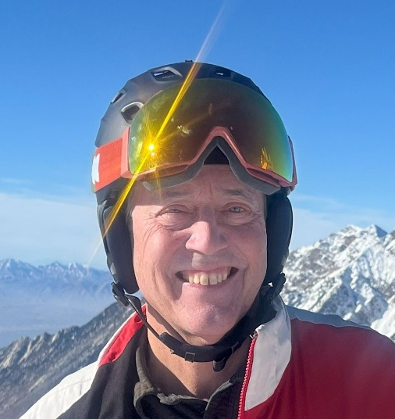
I have been a club member since I moved to the DMV in 2017. I have generally attended one or two trips each year since. I have led two developmental trips and one Western trip to Snowmass. I am preparing to lead the Kitzbuhel trip this year. I also played volleyball with the club for several years.
I have utilized technology in my trip leadership to include online trip documents, RSVP’s, and WhatsApp groups for pre-trip, travel and on-mountain communication. The WhatsApp group allowed one of our travelers to find another ride when his driver fell ill on the way to Canaan Valley. It does truly take a village. Importantly, the driver returned to good health and is skiing again.
I work in finance for the government contracting industry. I have a 17-year-old daughter who still skis with me, a ten-month-old puppy and an adult cat that loves them both. I also play volleyball, mostly on the Mall and in Arlington.
Rita Togni
- *A member of the Ski and Sports Club since the early 90’s
- *Currently serving on the Board of Directors for the past 4 years
- *Ski trip leader for many years, leading USA and European trips
- *Hiking leader for several local hikes
I enjoy skiing, hiking, tennis, pickleball and other sports with family and friends. The Club has evolved and expanded from being only a ski club to including other sports and social events. Volunteers work hard to make it successful.
I would like to work on finding venues to hold pickleball events at reasonable prices this is the fastest growing sport in USA and finding a location is the main challenge. We started with few Pickleball events In Northern Viriginia, but we need to expand to include Maryland and DC members. Re-instate Hiking at all levels, is another area we need to expand.
My background?
I lived in many different countries in Europe, South America and the Middle East.
Large family... skiing and tennis was always our common interest.
Professionally? I worked as an Architect, Interior Decorator and Designer. I am currently in Residential Real Estate.
I ask for your vote and support; we need to work towards a club for all seasons, all ages... and all budgets. Thank you.
Joe Trincellito
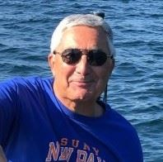
- I joined the Ski Club about seven years ago, after retiring for the second time, but my familiarity with the club goes back to the early 70s during my first assignment in DC. I have a Bachelor’s degree in Geology from SUNY-New Paltz and a MPA degree from George Washington University. My professional career in government spanned 29 years with several law enforcement related agencies (DEA, INTERPOL and Justice’s Criminal Div.) followed by 15 years providing consulting services, primarily involving foreign police and rule of law programs. Over the last 20 years, I have been active as a member of my Condo board. Much of that time I acted as Treasurer overseeing multi-million dollar operating and capital investment budgets.

I find myself skiing less and less, as my knee gets less and less cooperative, but I remain active with other activities, including the Nominating Committee, Happy Hours, Wednesday golf and travel golf trips. I believe my management and budgeting experience could be useful to the Club in navigating its ever-changing financial environment. I also believe that there is room for growth. As the demand for travel ski trips and adventure travel shows, there is a large community who desire such programs and much of it as yet untapped.

OTHER DOCUMENTS
NOTE: AGENDA DOCUMENT IS FORMATTED IN A CERTAIN WAY, DOES NOT TRANSFER WELL INTO THIS DOCUMENT. SEE SEPARATE DOCUMENT IN 3 PAGES.
NOTE: THE ELECTION IS SCRIPT IS SEPARATE ISPAGES LONG, SEE SEPARATE DOCUMENT,
4 PAGES
NOTE: THE BALLOT IS A SEPARATE, SPECIALIZED DOCUMENT, SEE SEPARATE DOCUMENT, 1 PAGE

